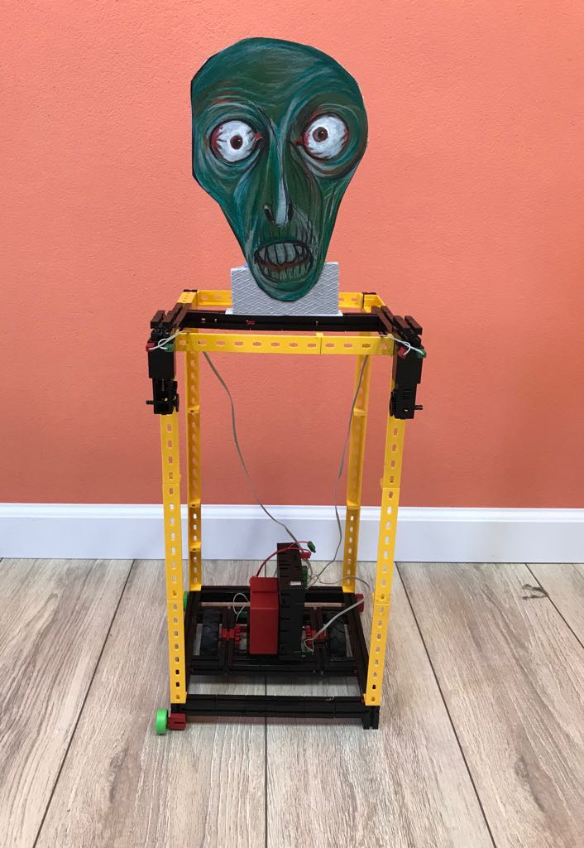
Monster

In order to enable the robot to move smoothly and maintain balance, we have made a structure of three-row black Fischertechnik cubes to ensure stability. In the middle line there are two engines that drive the robot. The main chassis is on the engines. On the outer corners of the construction are mounted 4 auxiliary chassis without a motor. Also, the main engines are supported with a TXT interface and 8.4 volt battery. To reduce weight, we used yellow and light Fischertechnik cubes to build a robot body. We are using ultrasonic sensor.
We are programming in RoboPro.

